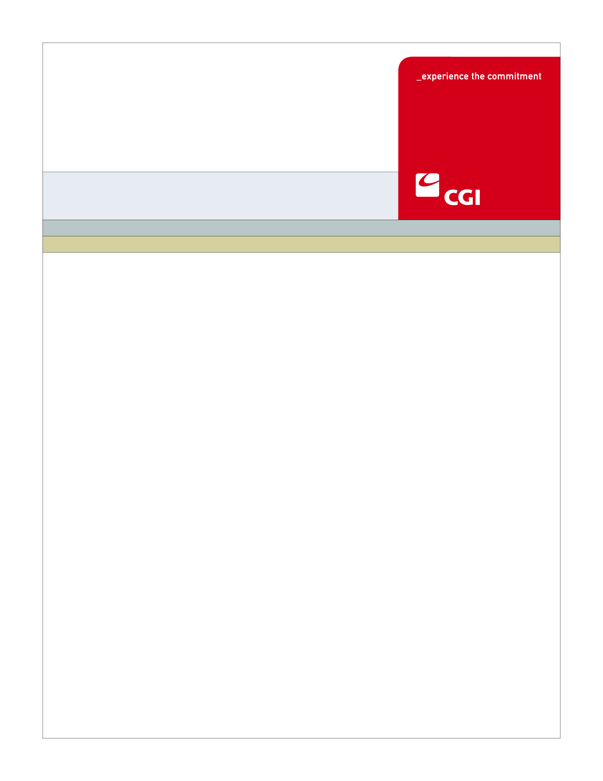USE

**Colorado Health Benefit Exchange (COHBE)**

**ELG-005**

**SUMMARY FOR**

**REPORT LIFE CHANGE**

**EVENTS**

**Version 2.0**

January 10,2013

REVISION HISTORY

|  |  |  |  |
| --- | --- | --- | --- |
| Version | Date | Modified By | Description |
| 2.0 | 2013-01-15 | Priyanka Gade | Approved Version |
|  |  |  |  |
|  |  |  |  |

TABLE OF CONTENTS

1 Report Life Change Events 1

1.1 Use Case Overview 1

1.2 Use Case Use Cases 2

1.3 Solution Component Matrix 2

2 Use Case Considerations 3

2.1 Assumptions 3

2.1.1 hCentive 3

2.2 Issues 3

2.3 Risks 3

2.4 Critical Dependencies 3

2.5 Performance Considerations 3

2.5.1 <Performance Consideration Name or Title> 3

2.6 User Impacts 4

2.6.1 <User Impact Name or Title> 4

3 Architecture and Network 5

3.1 System Architecture 5

3.1.1 System Architecture Diagram 5

3.1.2 Communication/Network 5

3.1.3 Hardware Resources 5

3.1.4 Third Party Software 5

3.1.5 Process Flows 5

3.1.6 Process Flows 5

Appendix 6

Appendix X – Acronyms, Terms 6

Appendix X – Document References 6

Appendix X – <Appendix Name> 6

# Report Life Change Events

## Use Case Overview

The Report Life Change Events use case will allow the customer to report their life status changes within the Exchange. Depending on the reported life change event the customer’s exchange subsidies may be recalculated, current plan may be dis-enrolled and/or a special enrollment period may be opened for the customer accordingly (Dis-enroll Plan - ELG---). In this process, the Exchange will determine the actions to be taken which can be an automatic trigger to the interface with the External Eligibility Service or the Exchange may request the additional documentation from the customer, but the later will not hold up the processing of the customer’s life change event. The System shall include the required rules, workflows and other tools to support the required eligibility business processes and automatic or manual re-determination of the eligibility for individuals.

Individuals and Employees will enter the Exchange to update their account information for life circumstance change; in similar fashion a Broker can also enter the Exchange to update account information on behalf of the client for a life circumstance change. The Exchange will check if the life change event qualifies to be automated and if the request can be automated then Exchange will determine if the changes are valid and re-determines the eligibility criteria if needed (Determine Individual Eligibility Use Case- ELG002). The Exchange will as well notify the Carriers of the life change events. Depending on the type of life change event, the Individual or Employee will be given a special enrollment period, the user should be allowed to continue with his current plan if it is still available, most importantly the Exchange features will comply with COBRA and other laws requiring the insured have the right to maintain any particular coverage for any period of time. The Exchange will send a notification to the Customer indicating that the exchange has granted the customer a special enrollment period or that the customer can come shop during the annual enrollment period based on Customer type (Individual or Employee), when both the start and end dates of the calculated special enrollment period fell within the annual enrollment period. As part of the process, Exchange will determine if the customer is an Individual or an Employee to proceed with the shopping experience needed due to the life change event that occurred. If an Individual he allowed to Shop for Individual Plan (ELG---), If an Employee the Customer/Employee is granted a special enrollment period in order to choose a new plan.

In case the life change event does not qualify for the automated process then the back office will manually process and validate the account change that the customer submitted within the Exchange.

## Use Case Use Cases

Table 1.1: Use Cases

| Reqt. No. | Description | Use Case No. |
| --- | --- | --- |
|  | Report Life Change Events | ELG005 |
| 2.1.7 | Determine Individual Eligibility | ELG002 |
| 2.1.12 | Shop for Individual Plan |  |
| 2.1.17 | Participate in shop enrollment period |  |
| 2.1.15 | Disenroll from plan |  |

## Solution Component Matrix

Table 1.2: Components

| Name | Description | Design Document |
| --- | --- | --- |
| **User Interface** |  |  |
| hCentive | User interface for individual eligibility assessment | EL-005_ReportLifeChangingEvents_hC_DetailedDesign |
|  |  |  |
| OSB | Oracle Service Bus Service | EL-005_ReportLifeChangingEvents _WS_DetailedDesign |
| SOA Suite | Oracle SOA Suite Services | EL-005_ReportLifeChangingEvents _WS_DetailedDesign |

# Use Case Considerations

## Assumptions

### hCentive

hCentive will provide expected input data in a request when invoking the web services in the OSB. Also it is critical for hCentive to invoke OSB web service with complete requested data for reporting the life change event workflow and for individual eligibility check.

## Issues

None at this time

## Risks

None at this time

## Critical Dependencies

The OSB service consumes all required self-attested data from hCentive. The data needs to be available, accurate, valid, and correct.

## Performance Considerations

### <Performance Consideration Name or Title>

None at this time

## User Impacts

None

# Architecture and Network

## System Architecture

### System Architecture Diagram

<Provide a diagram showing this solution’s components within system architecture with highlighting or some method to indicate the new components and/or connectivity which are a part of this Use Case>

### Communication/Network

<Provide a table or diagram showing this solution’s components communication with components from other systems/solutions – this section for showing communication and/or interfaces which may not appear or display well in the system architecture diagram above – optional when the information does display well in the system diagram above or ther eis really no important interface functionality in this Use Case>

### Hardware Resources

* Disk Storage <describe or identify disk storage and expected usage size>
* Memory <describe and identify expected system memory usage>
* CPU <if there is significant CPU usage identify it here>

<Note: optional, use this section to identify new resource associated with this Use Case>

### Third Party Software

<Use this section to identify and describe any third party software associated with this Use Case – optional when there is no third party software with this Use Case>

### Process Flows

### Process Flows

# Appendix

## Appendix X – Acronyms, Terms

| Acronym/Term | Description | Definition |
| --- | --- | --- |
| CHP+ | Child Health Plan Plus | CHP+ |
| QHP | Qualified Health Plan | QHP |
| APTC | Advanced Premium Tax Credits | APTC |
| CSR | Cost-Sharing Reduction | CSR |
| EES | External Eligibility Service | EES |
| ESV | External Source Verification | ESV |
| PEAK | Program Eligibility Application Kit | PEAK |
| CBMS | Colorado Benefits Management System | CBMS |
| MMIS | Medicaid Management Information System | MMIS |
| FPL | Federal Poverty Level | FPL |
| PII | Personal Identifiable Information | PII |
| OSB | Oracle Service Bus | OSB |
| OIT | Office of Information Technology | OIT |

## Appendix X – Document References

| Document Number | Title |
| --- | --- |
|  |  |
|  |  |

## Appendix X – <Appendix Name>

<Provide appendix information here>